**UML Modeling**

Link to Lucidchart: <https://lucid.app/lucidchart/invitations/accept/6aee5bc7-ba7f-4ce8-8615-9c75ad28843d>

Preview:

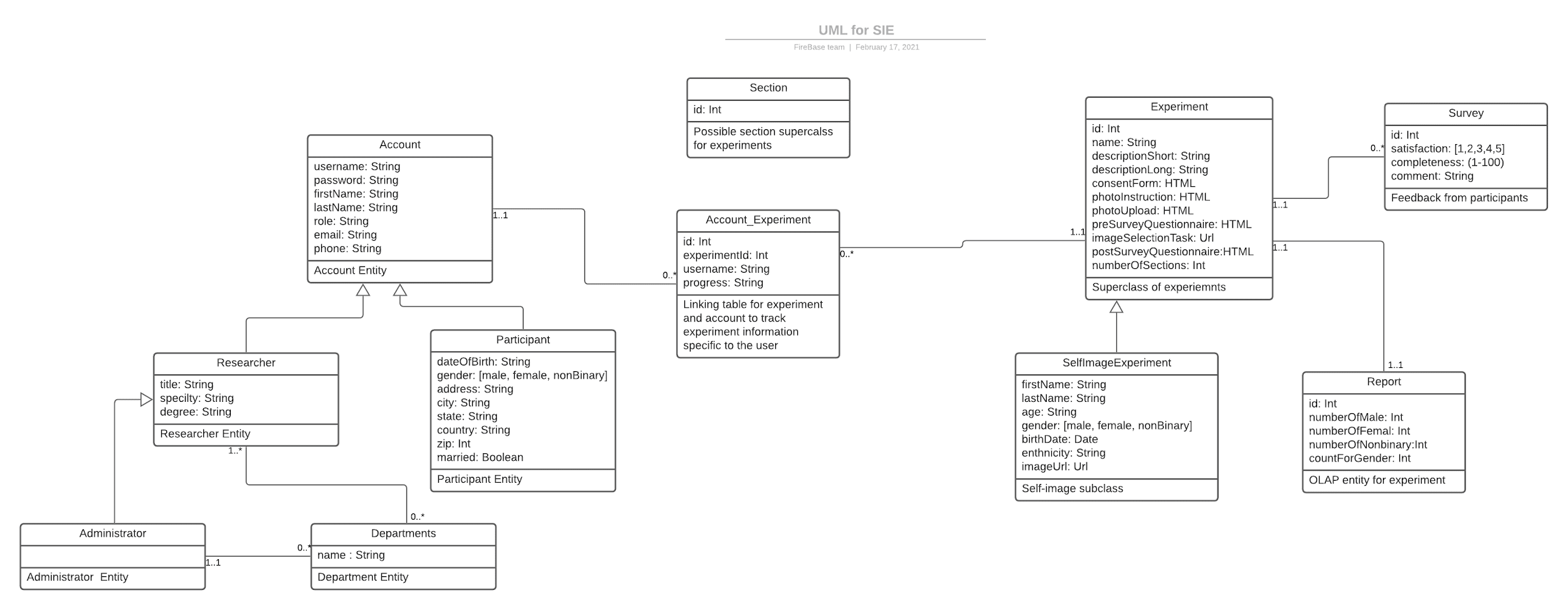

Comments: *Please leave your comment below about the model*

1. *Participant Entity*
   1. *Alessia: I don't think we need address related info. Possible additional fields are: Ethnicity, Religion, Sexual Orientation. Also, I would change Married to a multivalue field: {Single, Married, Widow, Divorced, Domestic Partnership}*
2. *Department Entity*
   1. *Alessia: No need for department. Researchers can come from different universities*